Sign up with Join Code [App]
You can sign up using your school join code through any web browser or by downloading the iOS or Android app on any compatible device. See below for step by step instructions on signing up through the App:
Sign Up via App:
Step 1: Download the "PLT4M" app by searching for it in your App or Google Play Store
Step 2: Choose the "Athlete" option
Step 3: Choose the option to "Sign Up With Join Code"
Step 4: Enter your school Join Code….. 74MAC
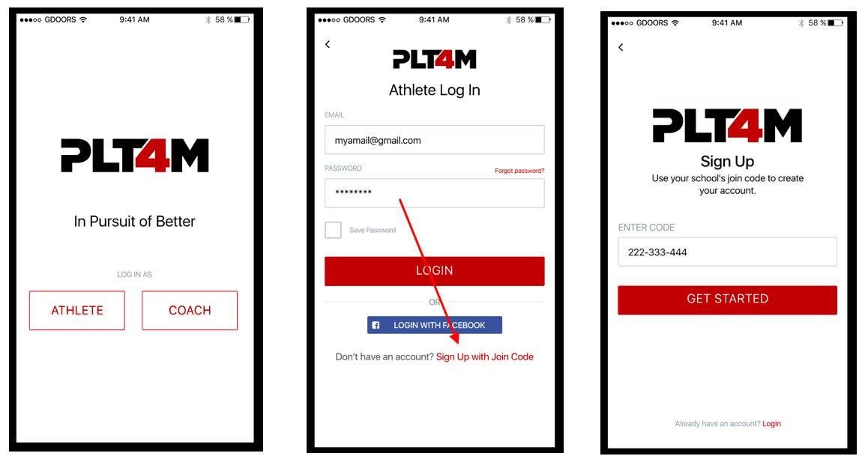
Step 5: Enter you Email, Name, and choose a Password
Step 6: Enter your Sport(s)/Position(s) - Don't play a sport? Enter "Phys Ed" and "Student"
Step 7: Enter Gender, DOB, Level and Grad Year
Step 8: If your coach/teacher has set up groups, you can find and join them in the final step.
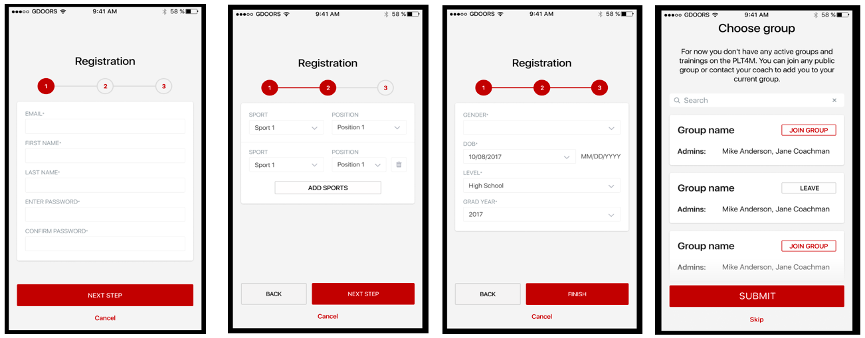
---------------------------------------
Video Tutorial:
https://help.plt4m.com/article/150-join-code-sign-up-via-app

Requirements:
iOS: The iOS app works with any iPhone or iPad that runs iOS 10 or later. While it will work with iOS 9, it is not supported, and consequently may experience some bugs.
Android: The Android app works with any Android phone or tablet. While Amazon Fires run a version of Android, the app is not built for Fires and may not be compatible.

Still need help? Contact Us
Last updated on September 18, 2019

Toggle Search

CATEGORIES
- Getting Started
- Web Version
- Mobile App
- FAQs
© PL

