Students should follow these instructions to join your class with a Google account or email address.
1. Open the Seesaw Class app on iOS or Android. Or go to app.seesaw.me on any computer in Chrome or Firefox browser.
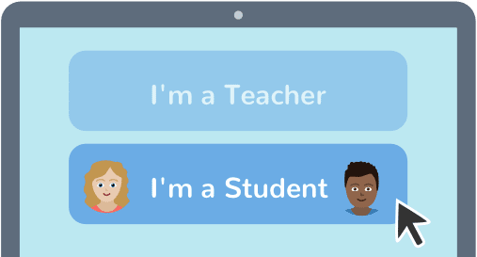
2. Choose I’m a Student.
ATTO SQPC
3. Type in this code to join your class. Students will only use this code once.
For security, there is a new code every 7 days.
Never share codes on social media.
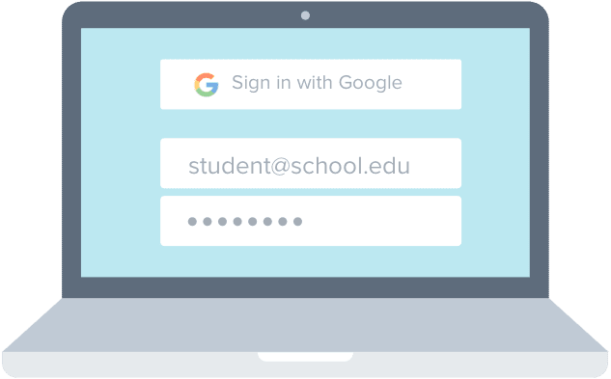
4. Sign in with your Google account or create an account with your email address and password.

